Class Digram :

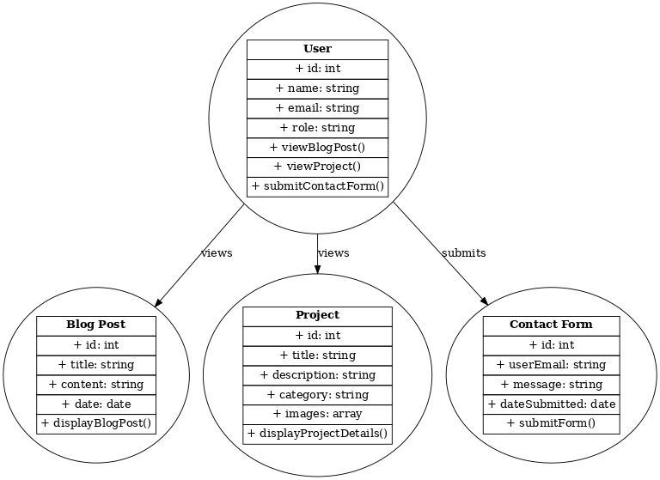Sequence Diagram:

